VISVESVARAYATECHNOLOGICAL UNIVERSITY
Jnana Sangama, Belagavi-560018, Karnataka, India



A Mini Project Report On
“Blockchain-Based Crowdfunding Platform”
Submitted in partial fulfilment of the requirement for the award of Degree of Bachelor of Engineering in Computer Science and Engineering
Submitted by
KOUSTAV DUTTA 1VE23CS082
MAYANK SINGH 1VE23CS100
MOHIT PAL 1VE23CS106 NEELOTPAL GHOSH 1VE23CS114

Under the Guidance of

Ms. PADMAVATHY S ASSISTANT PROFESSOR,
DEPT. OFCSE SVCE, BENGALURU


DEPARTMENT OF COMPUTER SCIENCE AND ENGINEERING
SRIVENKATESHWARACOLLEGE OF ENGINEERING
Vidyanagar,Bengaluru-562157 2025-2026

ABSTRACT

The Blockchain-Based Crowdfunding Platform is a decentralized application designed to enable secure, transparent, and trustless fundraising without intermediaries. Traditional crowdfunding platforms rely on centralized authorities, which can lead to issues such as lack of transparency, delayed fund distribution, and potential fraud.

This project leverages blockchain technology to ensure that all transactions are immutable, transparent, and verifiable. The platform allows users to create fundraising campaigns with defined funding tiers such
as Starter, Intermediate, and Advanced. Contributors can fund projects using blockchain-based transactio- --
-ns, ensuring secure and tamper-proof records.

Smart contract principles are incorporated to automate fund distribution based on predefined conditions. The system ensures that funds are only released when certain criteria are met, reducing risks for investors.

The application consists of a frontend interface for user interaction and a backend integrated with block chain logic for transaction processing. This project demonstrates how decentralized systems can change crowdfunding by enhancing trust, eliminating intermediaries, and ensuring financial transparency.

TABLE OF CONTENTS

Chapter No. | Title | Page No.
1 | Introduction | 1
2 | Literature Survey | 2
3 | Requirement Specifications | 4
 | 3.1 Functional Requirements | 4
 | 3.2 Non-Functional
 |  | 5
 | Requirements
 | 3.3 Software and Hardware
 | Requirements | 6
4 | System Design | 7
 | 4.1 Sequence Diagram | 7
 | 4.2 Data Flow Diagram (DFD) | 7

Chapter 1
INTRODUCTION

Crowdfunding has become an essential tool for startups, innovators, and social initiatives to raise funds from a large number of contributors. Platforms like Kickstarter and GoFundMe have simplified fundraising but still suffer from centralization issues such as:
- Lack of transparency in fund utilization
- Dependence on platform authority
- Transaction delays
- Platform commission fees

Blockchain technology addresses these challenges by providing a decentralized ledger system where all transactions are transparent and immutable.
Traditional crowdfunding systems face multiple challenges:
- Risk of fraud and misuse of funds
- Lack of transparency in fund flow
- Dependence on centralized intermediaries
- Limited trust between investors and project creators

The project focuses on Web-based decentralized crowdfunding system, Blockchain-based transaction recording, Multi-tier funding system and Real-time campaign tracking
Future enhancements can include mobile app integration and multi-chain support.

The main objectives of this project are:
- To develop a decentralized crowdfunding platform
- To ensure transparency using blockchain
- To implement secure and tamper-proof transactions
- To provide automated fund distribution using smart contracts
- To eliminate intermediaries and reduce transaction costs

Chapter 2
LITERATURE SURVEY

Bitcoin: A Peer-to-Peer Electronic Cash System – Satoshi Nakamoto (2008))

This foundational paper introduced Bitcoin and blockchain technology. It proposed a decentralized system where transactions are verified through cryptographic proof instead of trust. The concept of Proof-of-Work was introduced to validate transactions and prevent double-spending. This paper laid the groundwork for all blockchain-based applications.

Blockchain Technology: Principles and Applications – M. Swan (2015)

This study explored the applications of blockchain beyond cryptocurrency, including finance, healthcare, and supply chain. It highlighted blockchain’s key features such as decentralization, transparency, and immutability. The paper emphasized its potential to disrupt traditional centralized systems.

Secure and Efficient Blockchain-Based Transactions – K. Christidis and M. Devetsikiotis (2016)

This research focused on improving transaction efficiency and scalability in blockchain systems. It discussed challenges like high computational cost and latency in Bitcoin networks and suggested optimizations in consensus mechanisms.

Analysis of Bitcoin Blockchain Security – G. Wood (2017)

The paper analyzed security aspects of blockchain including cryptographic hashing, digital signatures, and resistance to attacks. It highlighted how blockchain ensures data integrity and prevents fraud through distributed consensus.

Blockchain Scalability Issues and Solutions – A. Croman et al. (2018)

This study examined scalability challenges in Bitcoin such as limited transaction throughput and network congestion. It proposed solutions like SegWit and Lightning Network to improve performance.

Smart Contracts and Blockchain Applications – N. Szabo (2019)

This work explored how blockchain enables automated agreements through smart contracts. Although focused on Ethereum, it provided insights into decentralized applications and programmable transactions.

Real-Time Cryptocurrency Transaction Systems – R. Gupta and P. Sharma (2024)

This recent research proposed efficient blockchain systems for real-time transactions with reduced latency. It emphasized optimizing mining and validation processes for better performance.

Blockchain-Based Financial Systems – IBM Research (2025)

This study discussed modern blockchain implementations in banking and finance. It highlighted improvements in security, transparency, and reduced dependency on intermediaries.

Chapter 3

Requirement Specifications

Functional Requirements

The functional requirements describe the essential operations and features that the system must perform.

User Authentication
      - Users can register and login using JWT authentication.
      - Wallet connection using MetaMask.

Wallet System

      - The system must generate public and private keys for users.
      - It should allow users to manage their digital wallets securely.

Contribution System
      - Users can fund campaigns using MATIC.
      - Transactions executed via smart contracts.

Smart Contract Module
      - Handles fund locking and validation.
      - Automates fund withdrawal and refunds.

Campaign Module
      - Create campaign with:
        - Title
        - Description
        - Funding goal
        - Deadline
- Edit or delete campaigns

User Interface

  - The system should provide an interface for initiating transactions and viewing blockchain data.

3.2 Non-Functional Requirements

These requirements describe system characteristics such as performance, scalability, and usability.

Performance Requirements

  - The system should process transactions efficiently.

Reliability

  - System must maintain data integrity and consistency.

Scalability
  - Should handle increasing number of transactions.

Usability

  - Interface should be simple and user-friendly.

Maintainability
  - Code should be modular and easy to update.

Portability
  - Should run on multiple operating systems.

3.3 Software and Hardware Requirements
- Software Requirements

Category | Specification
Operating System | Windows / Linux / macOS
Frontend | React.js (Vite)
Backend | Node.js with Express.js
Database | SQLite (Sequelize ORM)
Blockchain | Solidity (Polygon Amoy Testnet)
Web3 Library | Ethers.js
Storage | IPFS (Pinata)
Tools | Hardhat, VS Code, Postman

- Hardware Requirements

Category | Specification
Processor | Intel Core i5 / AMD Ryzen 5 or higher
RAM | Minimum 8 GB (16 GB recommended for model fine-tuning)
Storage | Minimum 10 GB free disk space

Chapter 4

  - Sequence Diagram

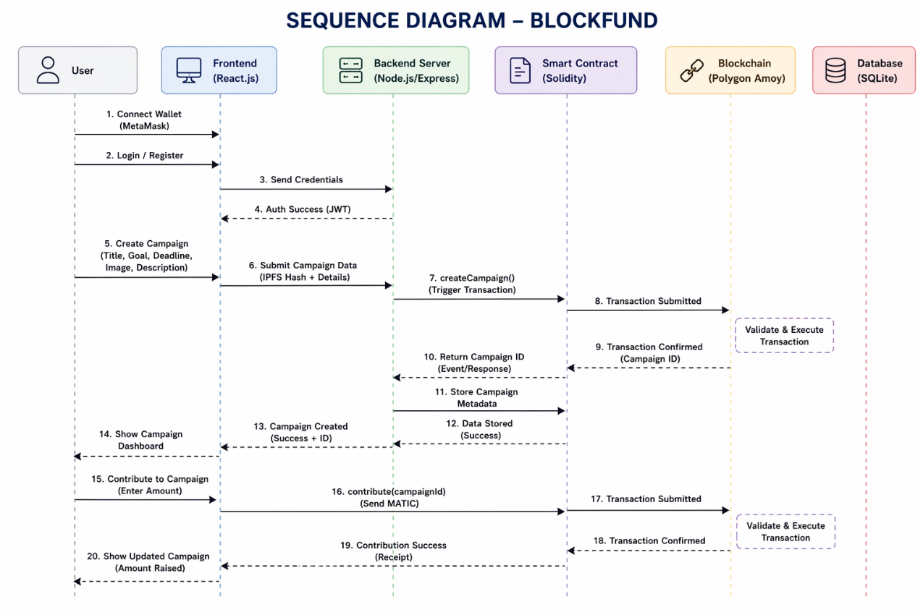

  - Data Flow Diagram
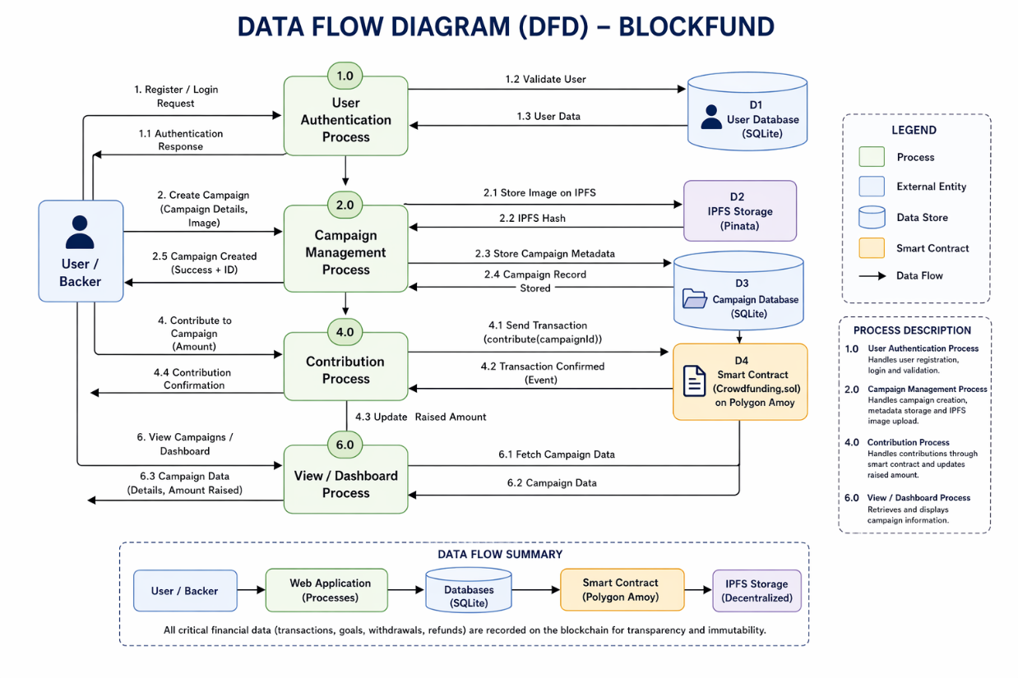
System Design

